To manifest a better insight into the properties of the data, we provide a series of interactive illustrations (https://tabsoft.co/2RErMBD) by leveraging the targeting attributes, in addition to election information collected from online resources.

Figure-1 is illustrating the distribution of political ads on Facebook based on geographical information collected from the targeting attributes. According to the map, users in highly populated states (Darker green relative to high regional population) like California, New York, Texas, and Washington are more prone to be targeted by political ads. Among the low populated states including Montana, South Dakota, and North Dakota, number of Facebook users who were targeted by political ads because of their state information was higher in North Dakota.

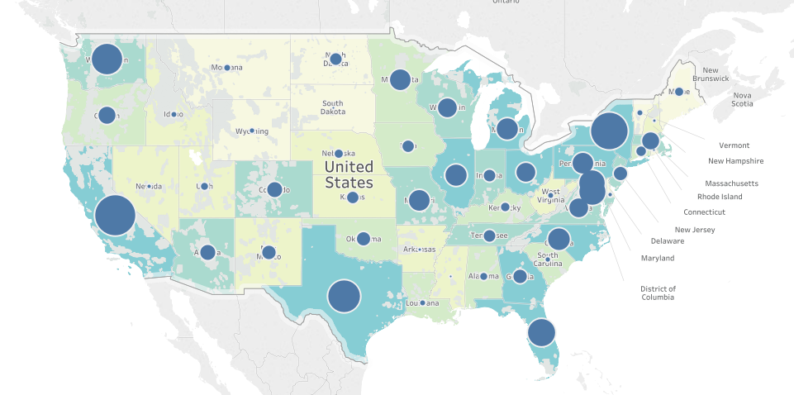

Figure-1 Number of Political ads on Facebook based on geographical Information

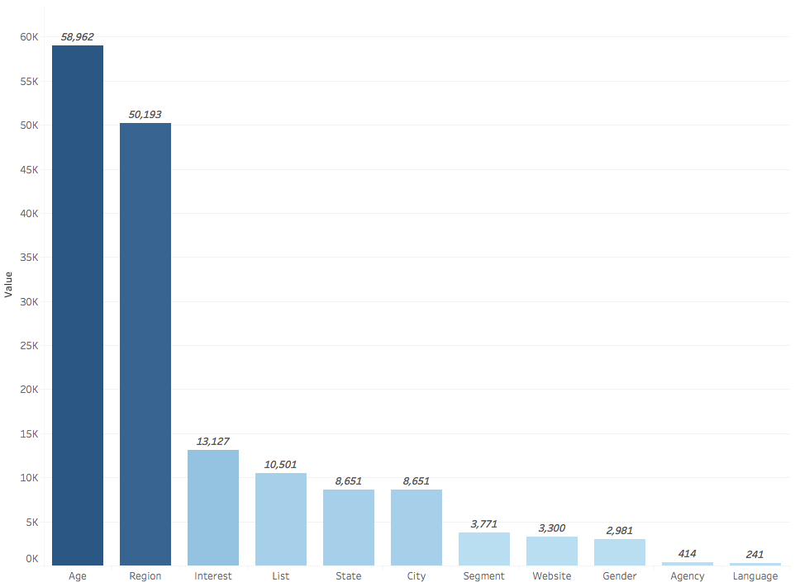

Figure-2 Distribution of number of political ads for targeting features

According to this chart the top two targeting feature for being targeted by political ads are age and region of Facebook users. More than 70 percent of the time Facebook users are targeted by political ads because they meet certain age and location criteria as opposed to language, agency, and gender by only 2 percent.

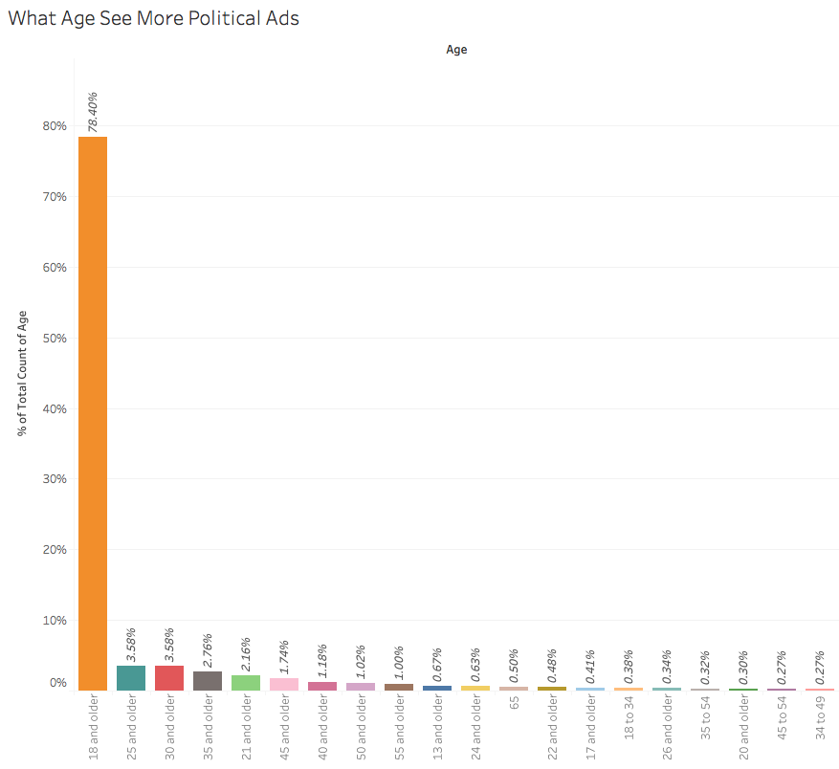

Figure-3 What age sees more political ads?

Being 18 years old and higher is the main factor to be targeted by political ads. On the other hand, old users are less prone to be targeted, by political ads.

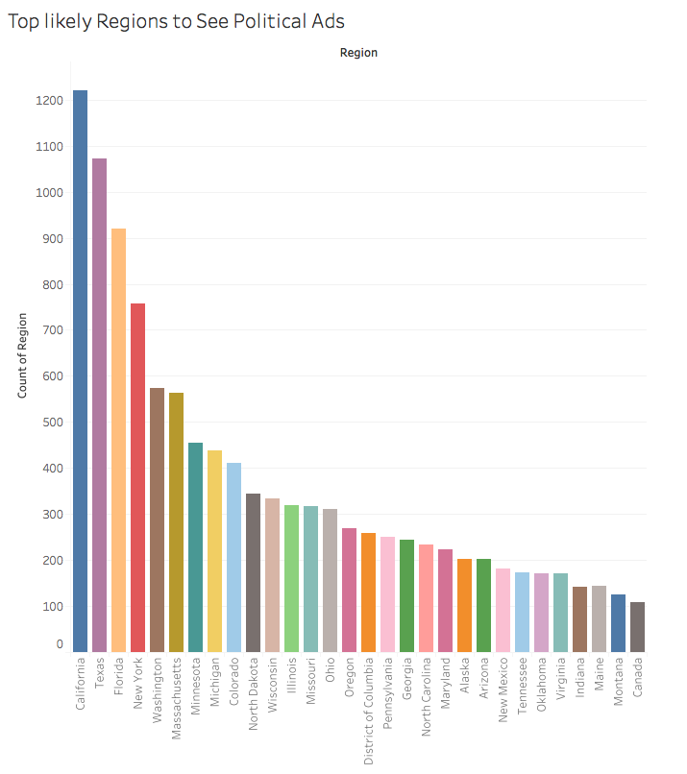

Figure-4 The distribution of political ads in different states

Region is the second important factor to be targeted by political ads. In Figure-4 Facebook users in California, Texas, Florida, and New York are almost 10 times more likely to be targeted by political ads than states like Indiana, Montana or even Virginia.

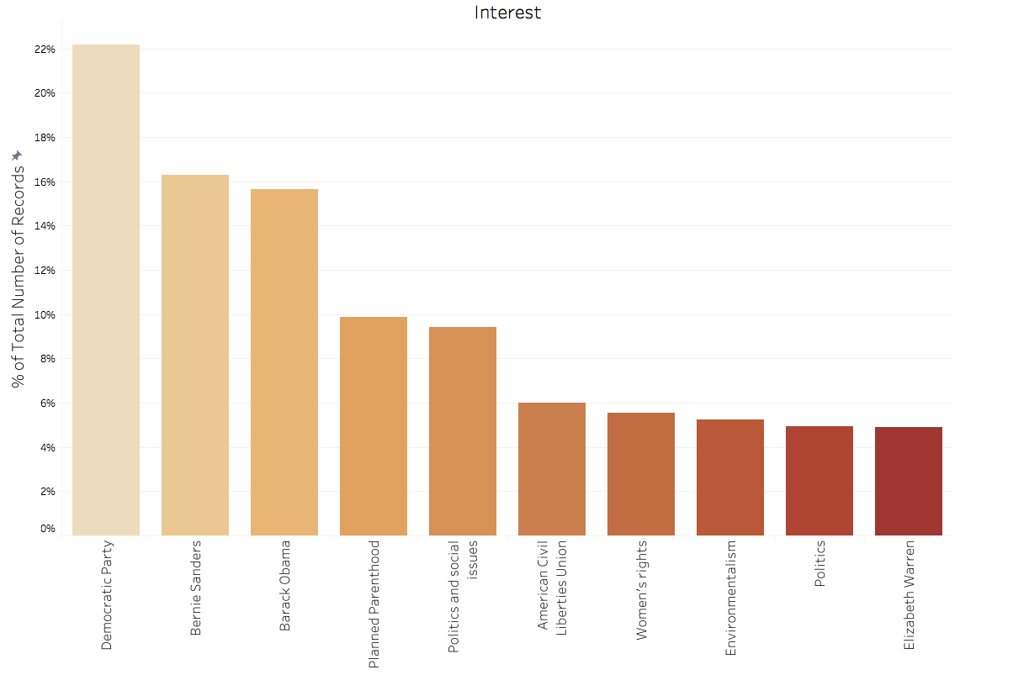

Figure-5 Top 10 Interest features used for targeting the political ads

After age and region, interest is the third category for political ad targeting. Figure-5 shows the top 10 features used in this category. According to the chart Facebook users with interest to Democratic Party, Bernie Sanders and Barak Obama are more prone to be targeted by political ads than the other interest categories.

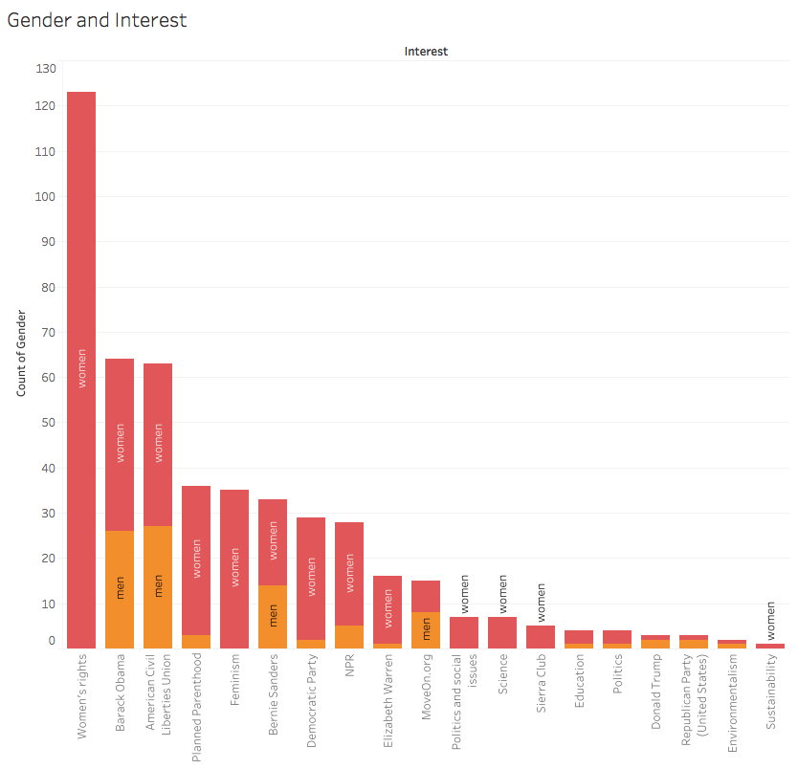

Figure-6 The combination of interest and gender targeting features

This graph demonstrates the combination of gender and interest category. According to Figure-6 and as being expected, we observe more interest of women toward “women’s right” and “feminism” but also women show more interest to Democratic Party, Planned Parenthood, Elizabeth Waren and Education.

Figure 7) Age and interest

This graph demonstrates top N interest attributes in different age categories. One of the findings from this graph is that the Facebook user in 30 years old and 35-55 age categories are more interested in women’s right and Planned Parenthood than younger users. In contrast, young Facebook users have more interest to Political issues, Bernie Sanders, Barack Obama, and Democratic Party.

Figure 8-9) Top N interest based on region and interest all over the state

In the first graph the distribution of different interest by regions are shown.

(Second graph is same information over the US map).

Figure 10) Age and region and population

This graph shows the distribution of different age categories all over the state.

Figure 11) Top 100 advertisers

This table sorts and illustrates the top 100 advertiser based on total number of ads posted by each. According to this chart Robert Francis who is an American businessman and politician who served Texas's in recent election ranked 1st  in advertiser. His opponent, Ted Cruz also is among the advertisers with relatively small number of ads who could also won the election.

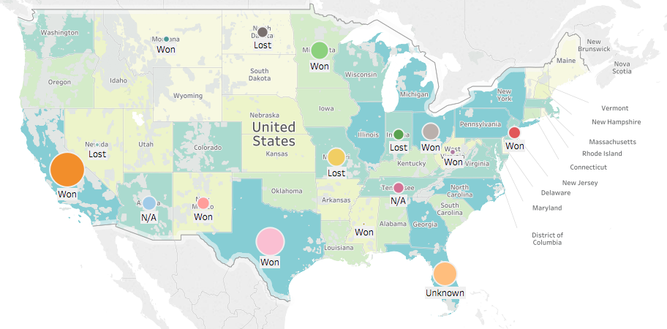

Figure12) Incumbent status for battleground states

Figure-12 shows the election outcome on the map in addition to the number of political ads for each state. This map is filtered to show only the battleground states, which play a key role in the election outcome. There is no significant coloration between the election outcome and the number of ads in battleground states.

Figure 13) Winner on Battle ground states.

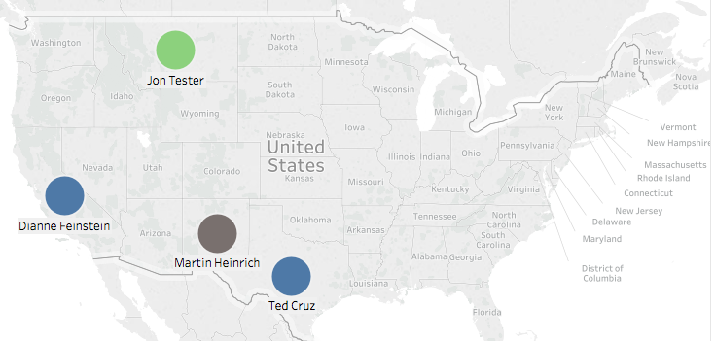

Figure 14-5) Advertisers and election outcome.

The first map illustrates the number of ads and list of the advertisers for the battleground states. Among all the candidates only Jon Tester, Dianne Feinstein, Ted Cruz, and Martin Heinrich are the candidates who are also advertiser and could won the election.